Silhouette metric for img015001.jpg is: 0.8084204573912711

Davies Bouldin metric for img015001.jpg is: 0.18100532651219858

Calinski Harabasz metric for img015001.jpg is: 125541.9800192519

ID 0: (135, 607)

ID 1: (58, 720)

ID 2: (1542, 653)

ID 3: (1728, 695)

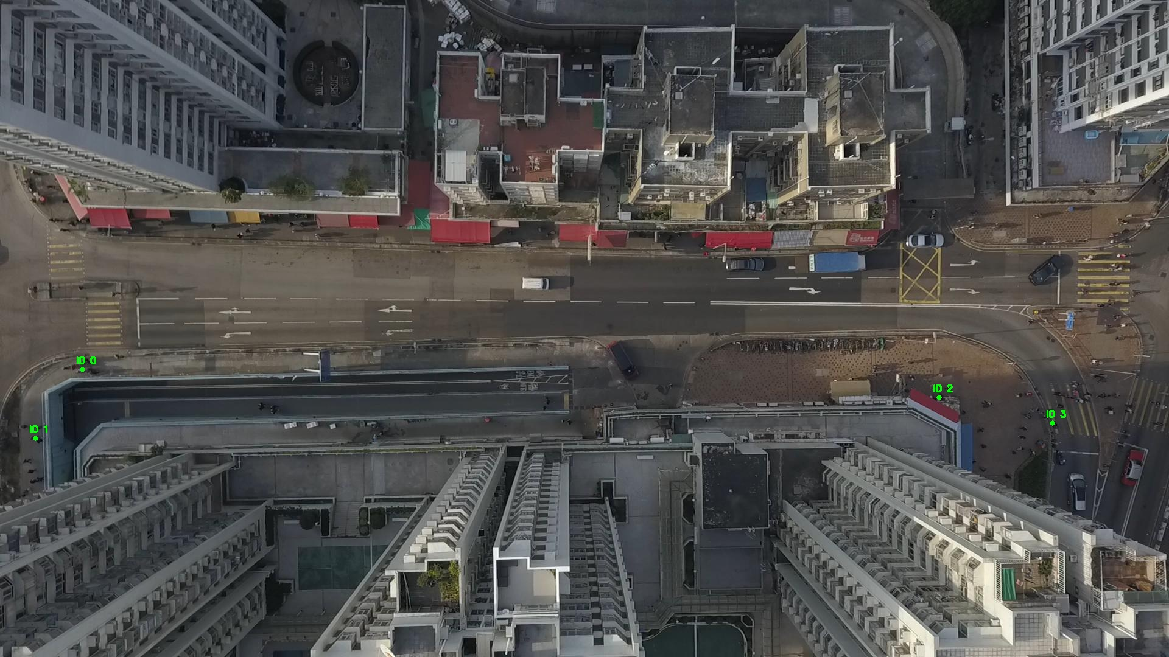

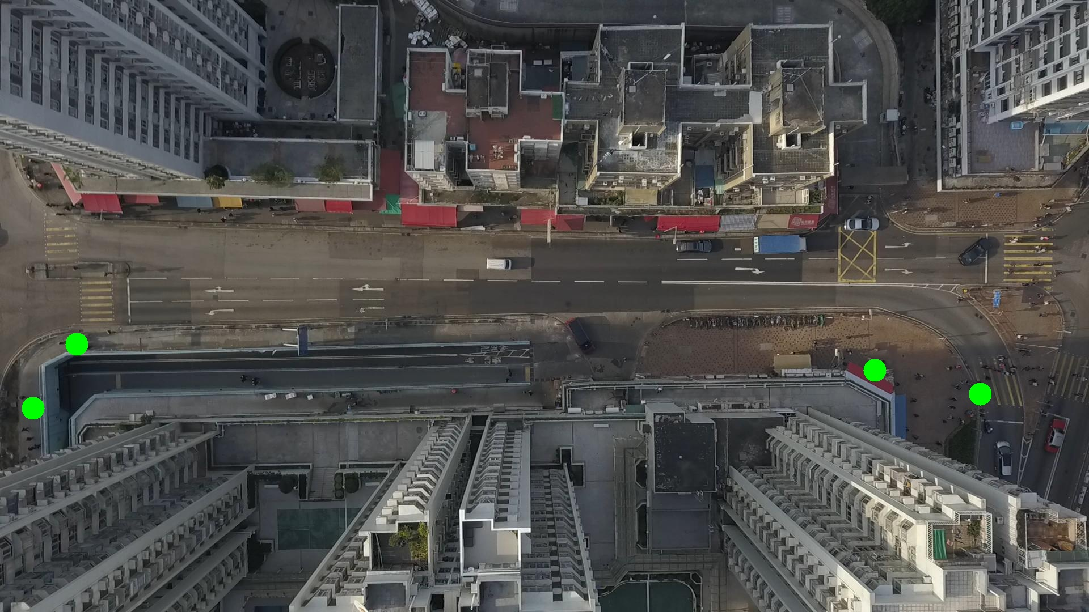

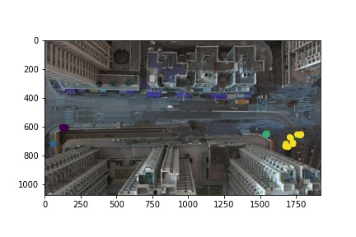

Silhouette metric for img015002.jpg is: 0.8083205745394247

Davies Bouldin metric for img015002.jpg is: 0.14569393180421403

Calinski Harabasz metric for img015002.jpg is: 150515.84688432535

ID 0: (133, 607)

ID 1: (44, 758)

ID 2: (1542, 653)

ID 3: (1736, 674)

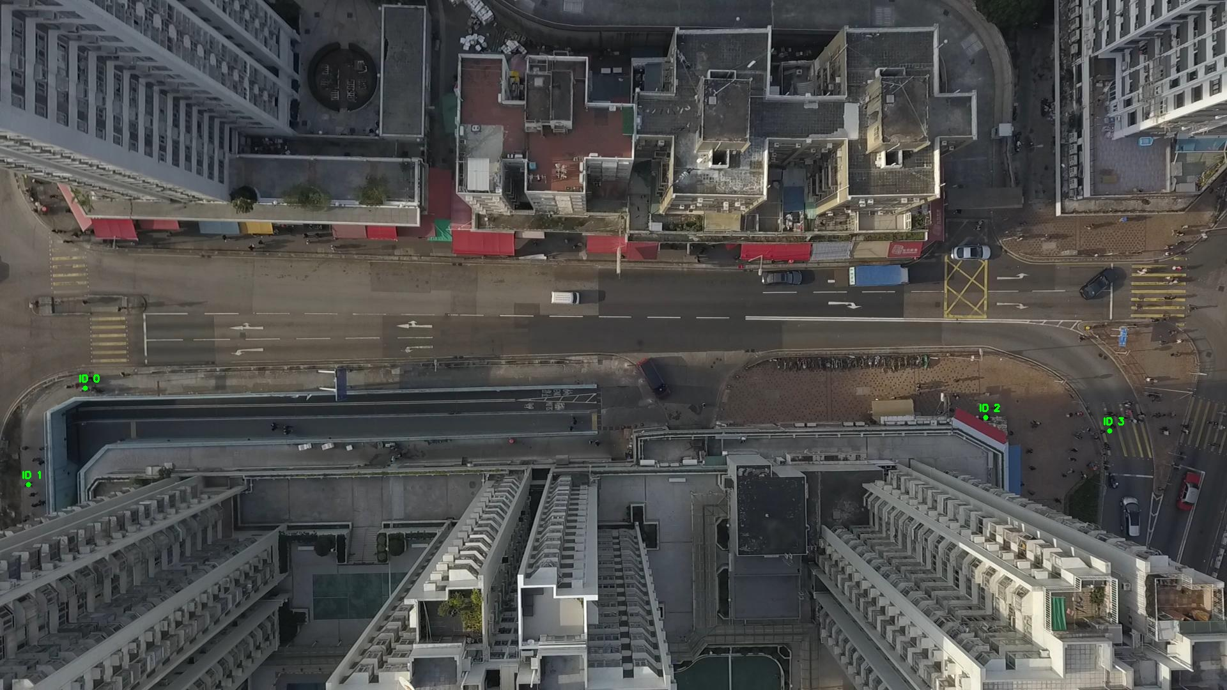

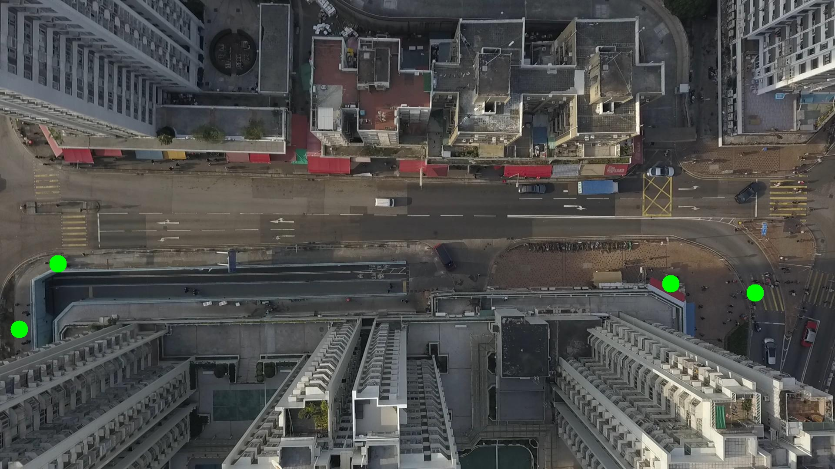

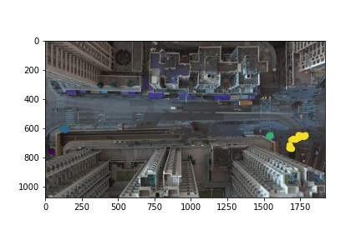

Silhouette metric for img015003.jpg is: 0.7787474906748844

Davies Bouldin metric for img015003.jpg is: 0.19819536548374045

Calinski Harabasz metric for img015003.jpg is: 108581.55385815824

ID 0: (133, 607)

ID 1: (53, 734)

ID 2: (1541, 653)

ID 3: (1725, 686)

ID 4: (333, 1053)

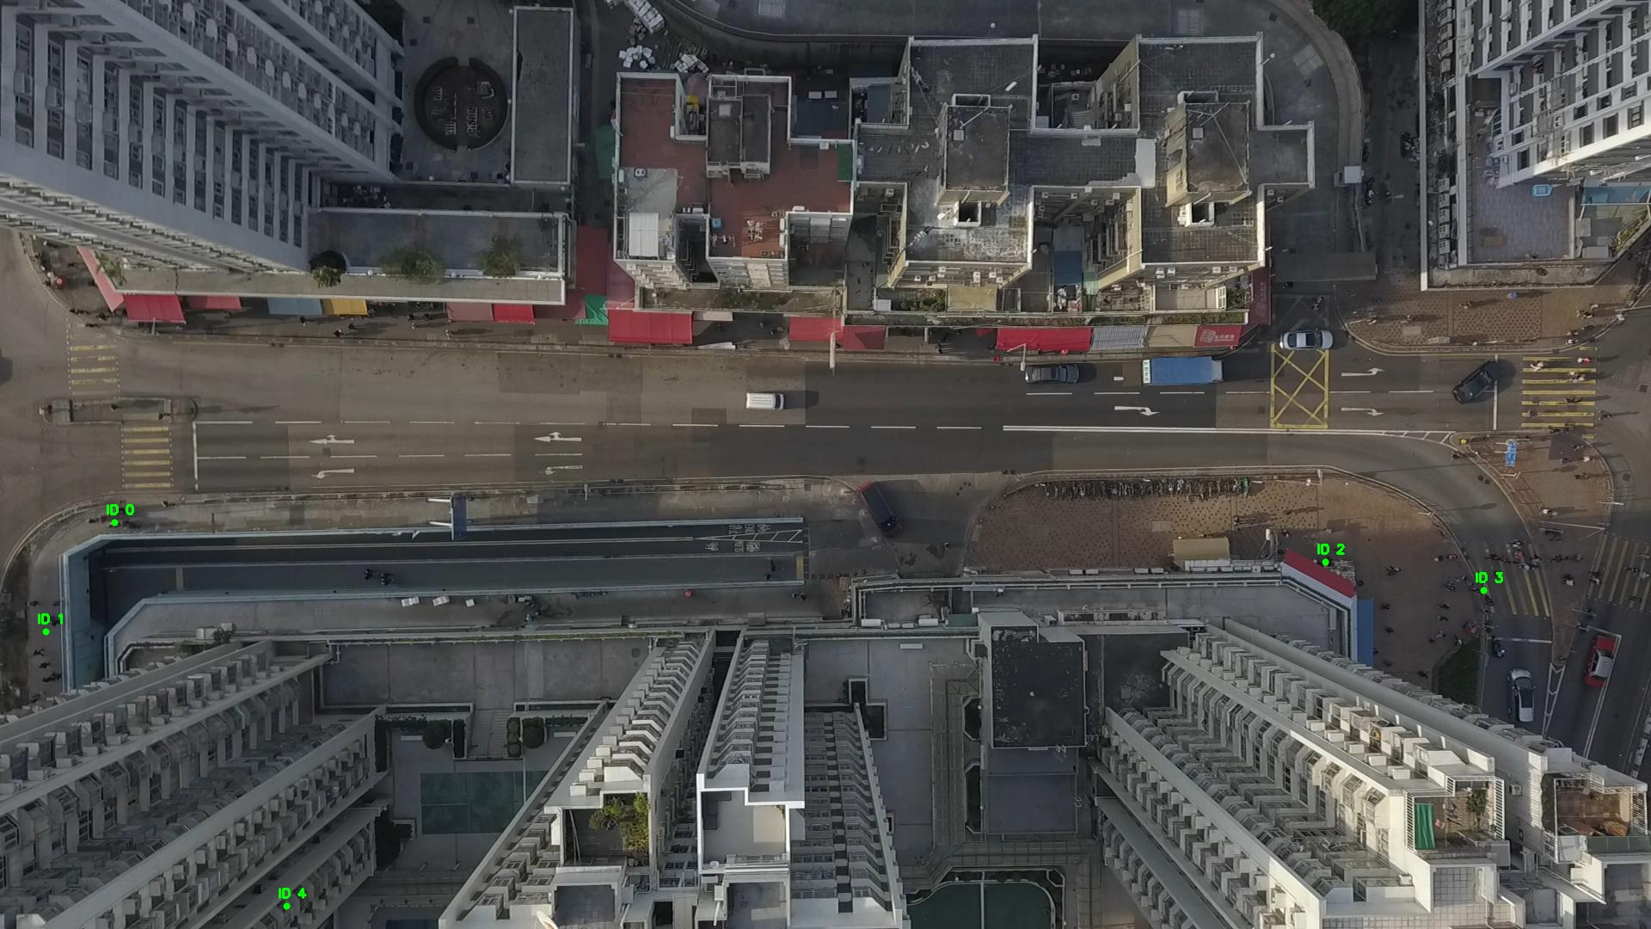

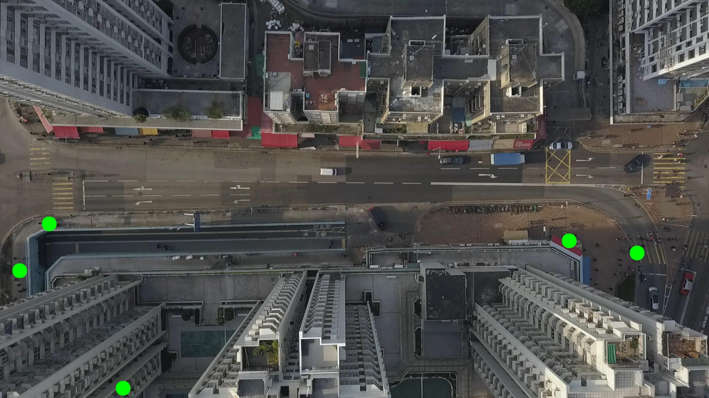

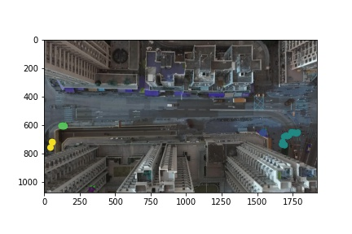

Silhouette metric for img015004.jpg is: 0.82674466109976

Davies Bouldin metric for img015004.jpg is: 0.21551470787670077

Calinski Harabasz metric for img015004.jpg is: 141923.4751434442

ID 0: (132, 607)

ID 1: (55, 723)

ID 2: (1543, 653)

ID 3: (1730, 687)

ID 4: (333, 1053)

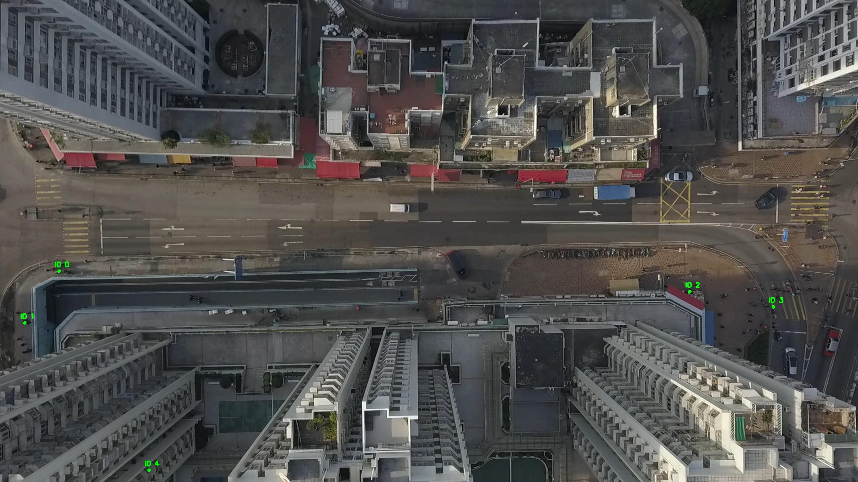

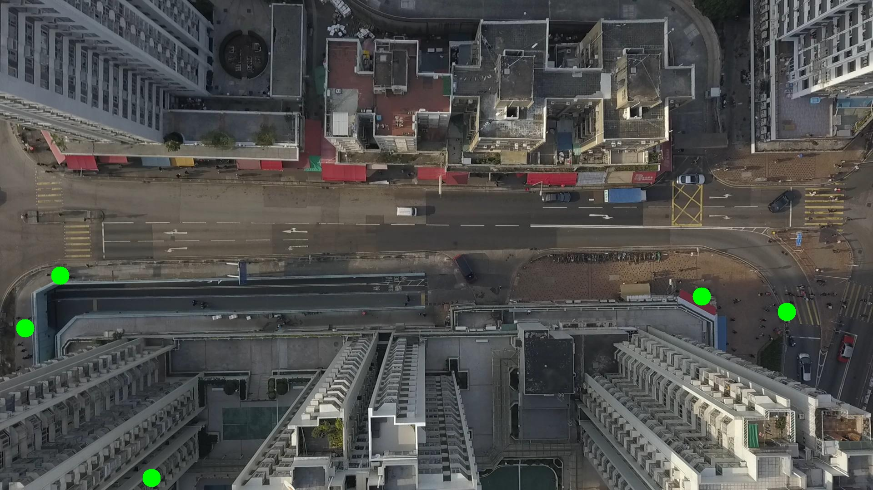

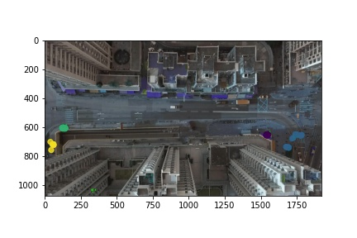

Silhouette metric for img015005.jpg is: 0.8717935276457589

Davies Bouldin metric for img015005.jpg is: 0.18086337561173488

Calinski Harabasz metric for img015005.jpg is: 182384.06215462327

ID 0: (132, 608)

ID 1: (60, 722)

ID 2: (1543, 653)

ID 3: (1712, 699)

ID 4: (333, 1053)

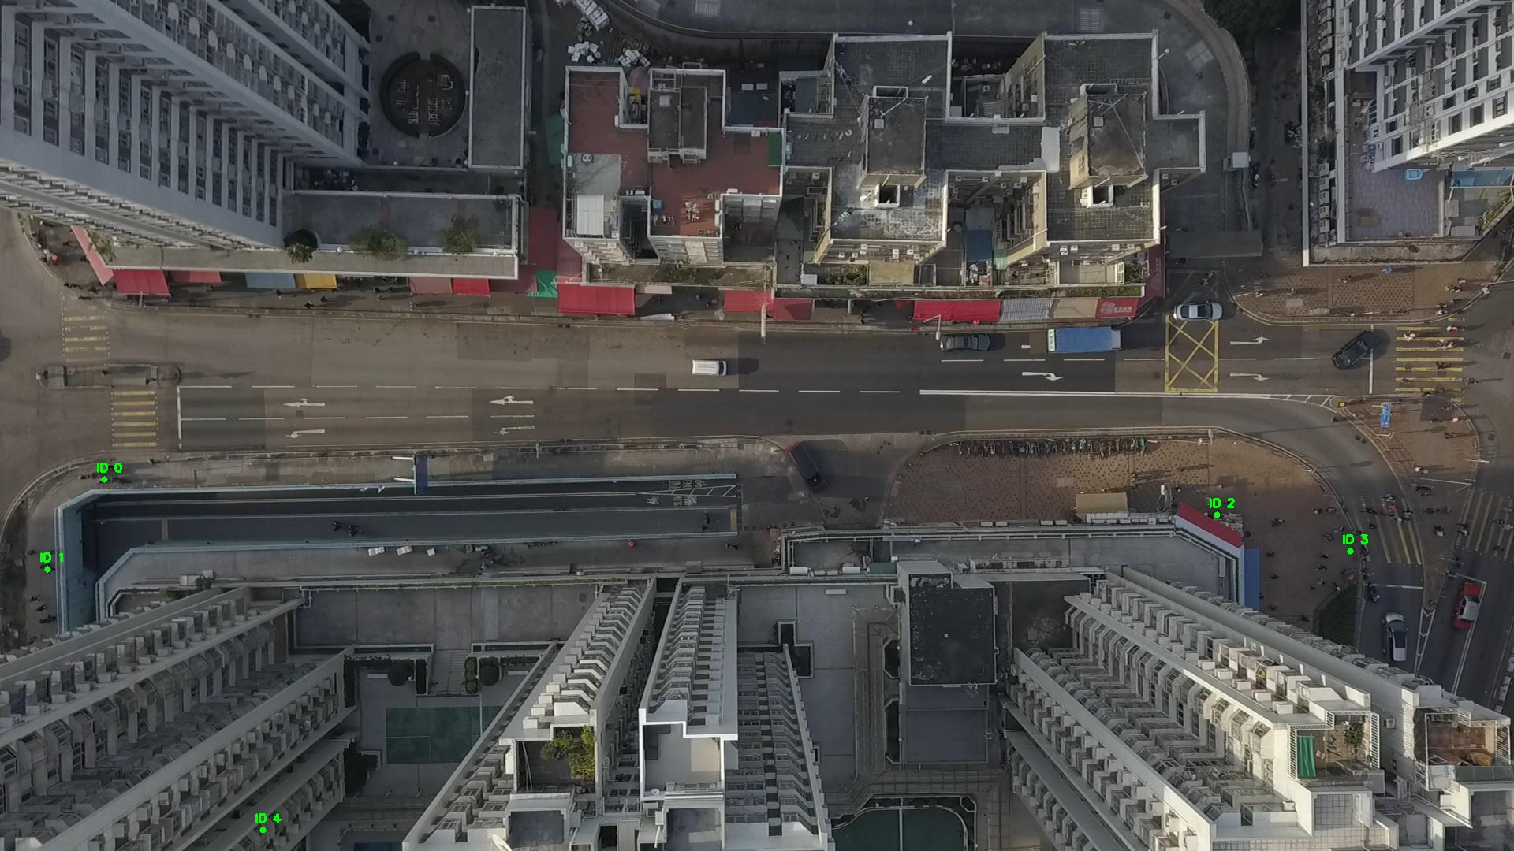

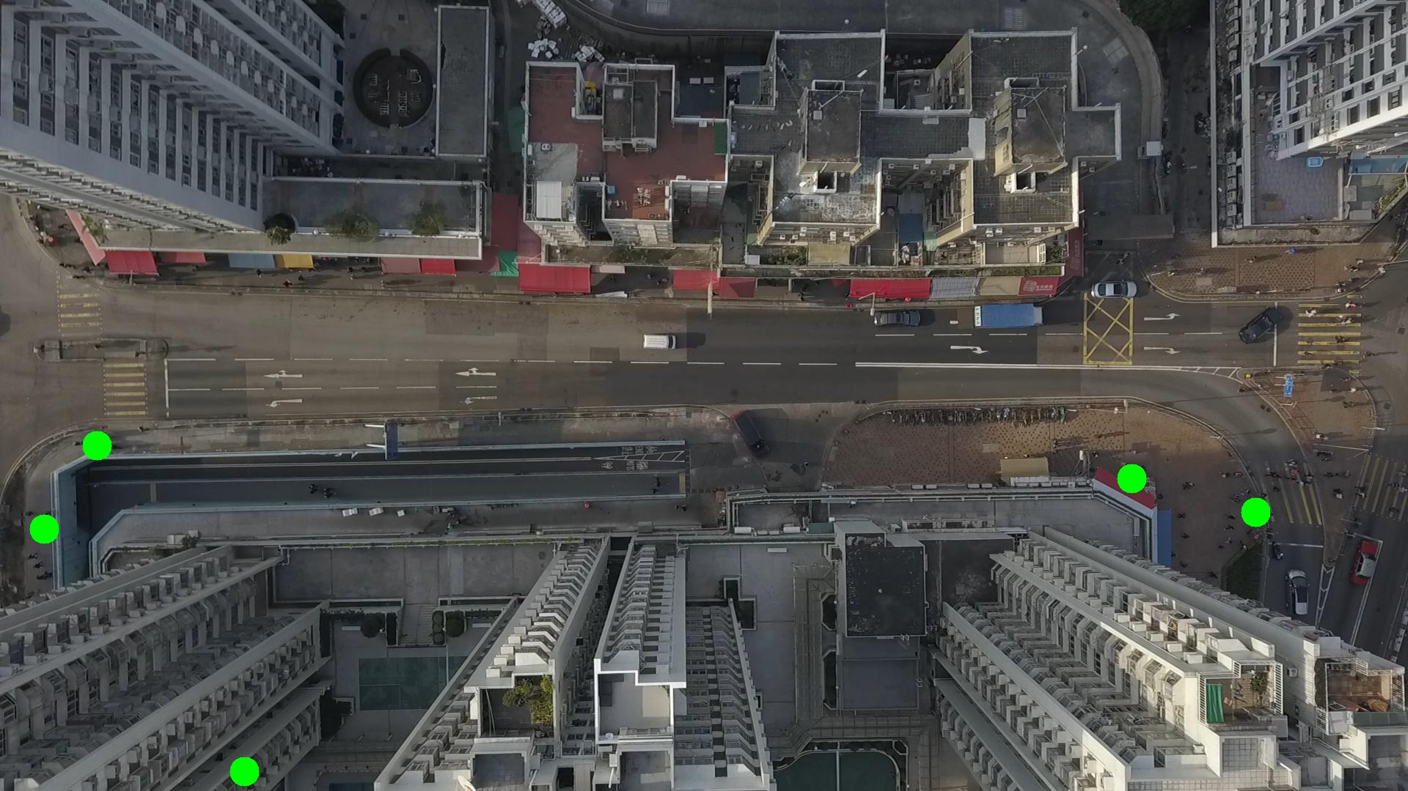

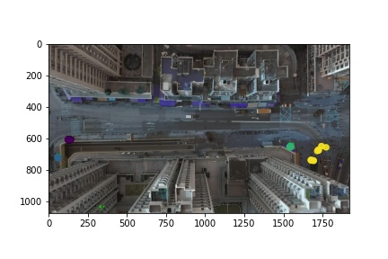

Silhouette metric for img015006.jpg is: 0.8605812379810466

Davies Bouldin metric for img015006.jpg is: 0.18769233212987935

Calinski Harabasz metric for img015006.jpg is: 151731.08815940848

ID 0: (132, 608)

ID 1: (61, 721)

ID 2: (1543, 653)

ID 3: (1738, 687)

ID 4: (333, 1053)

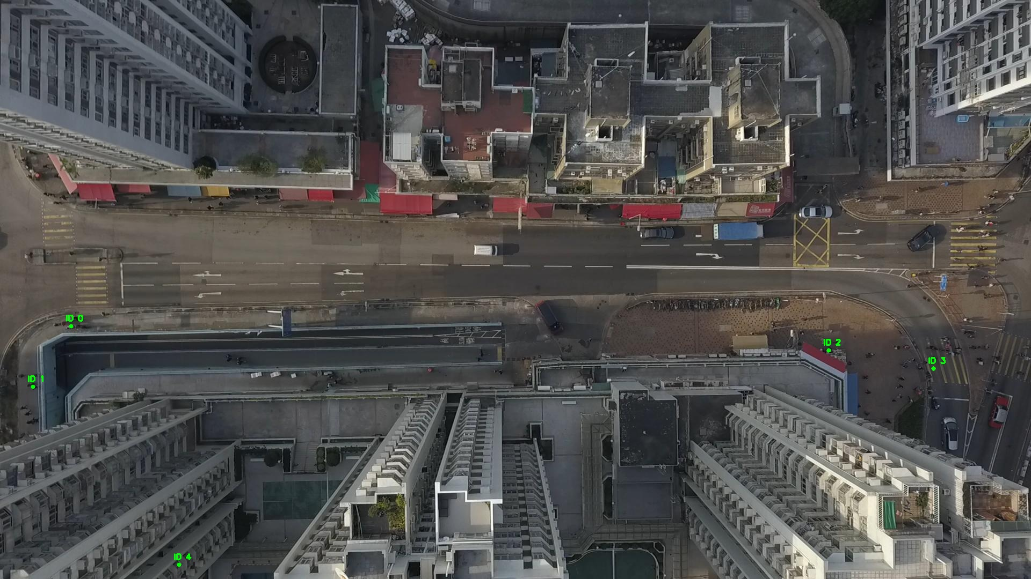

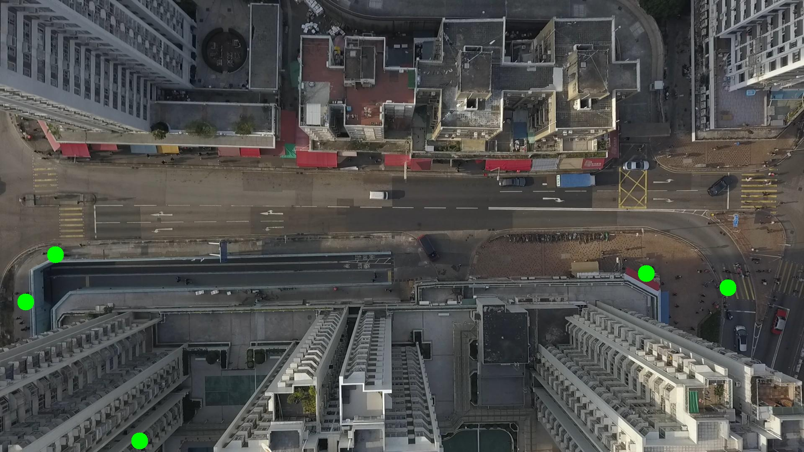

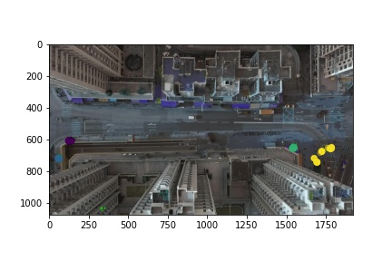

Silhouette metric for img015007.jpg is: 0.9118686145159013

Davies Bouldin metric for img015007.jpg is: 0.13772159963684996

Calinski Harabasz metric for img015007.jpg is: 287102.0070934996

ID 0: (131, 608)

ID 1: (61, 721)

ID 2: (1542, 653)

ID 3: (1712, 687)

ID 4: (333, 1053)

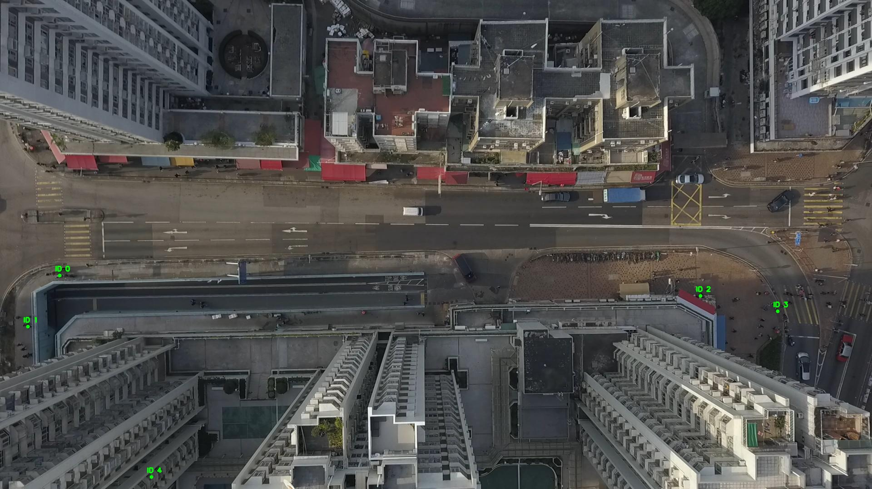

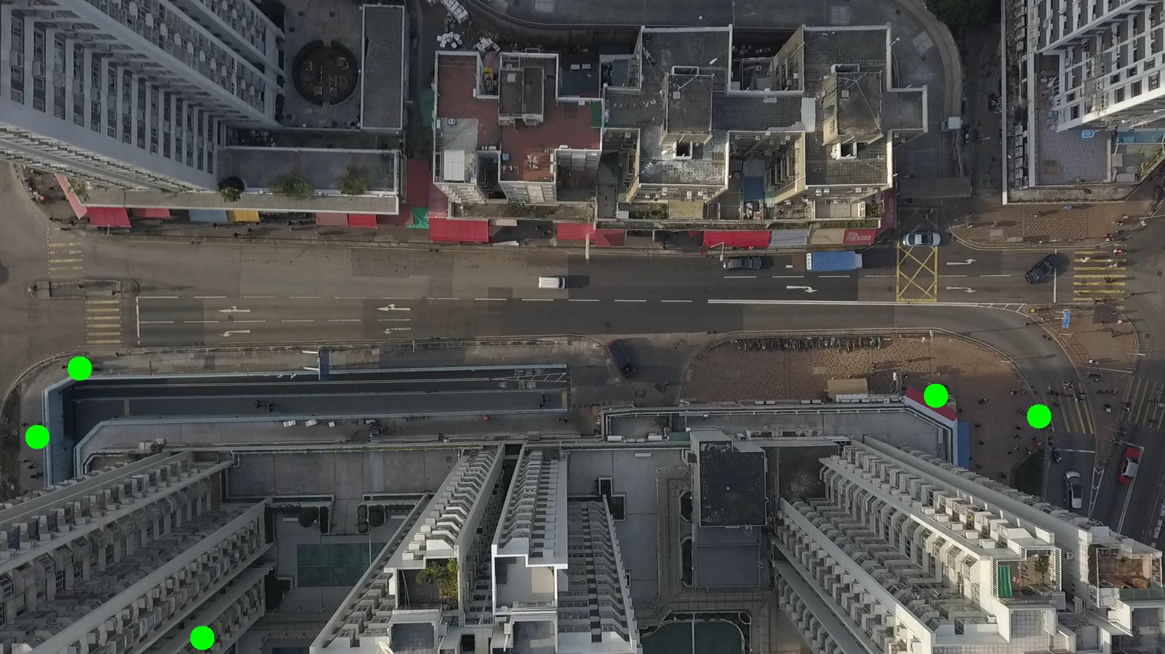

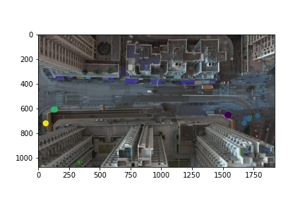

Silhouette metric for img015008.jpg is: 0.8520535882130161

Davies Bouldin metric for img015008.jpg is: 0.17742680159035618

Calinski Harabasz metric for img015008.jpg is: 166218.63821905057

ID 0: (133, 608)

ID 1: (59, 719)

ID 2: (1543, 653)

ID 3: (1713, 689)

ID 4: (333, 1053)

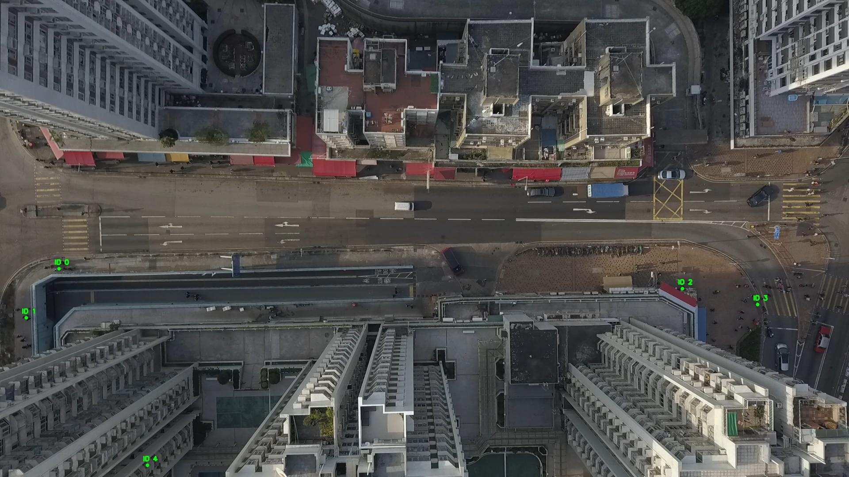

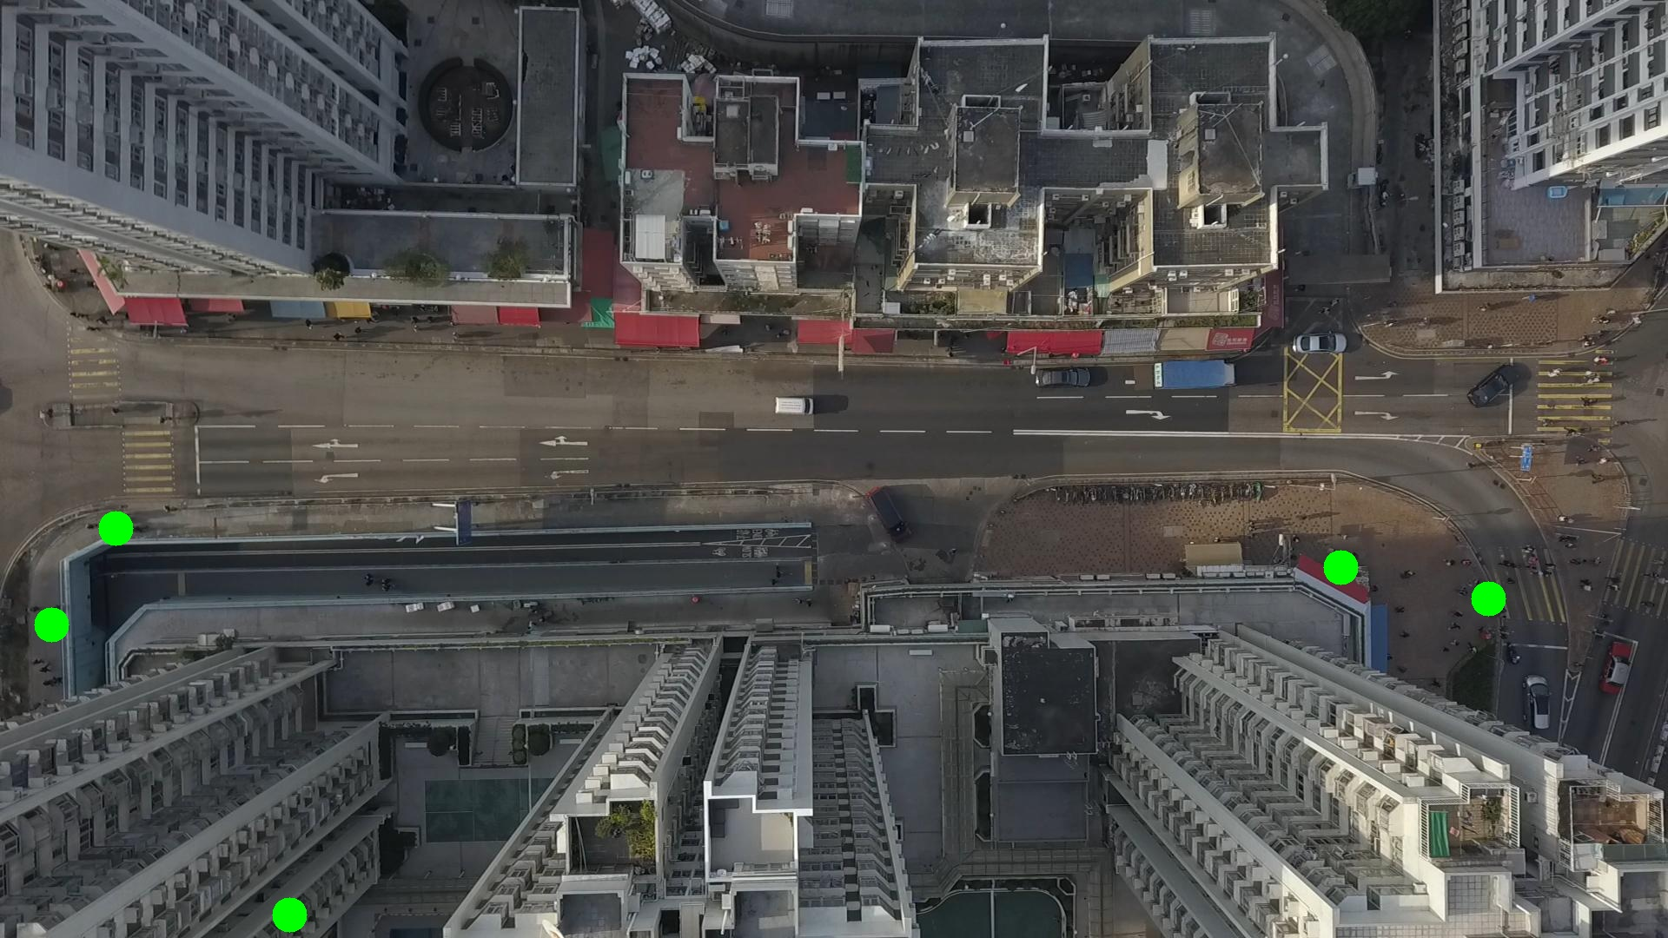

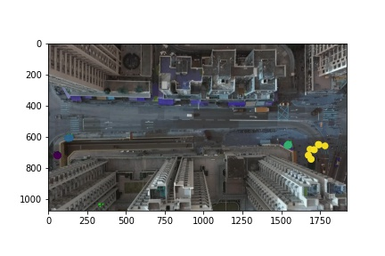

Silhouette metric for img015009.jpg is: 0.8342792698357275

Davies Bouldin metric for img015009.jpg is: 0.11614767319334655

Calinski Harabasz metric for img015009.jpg is: 51664.46234541718

ID 0: (137, 609)

ID 1: (61, 718)

ID 2: (1543, 653)

ID 3: (1743, 662)

ID 4: (333, 1053)

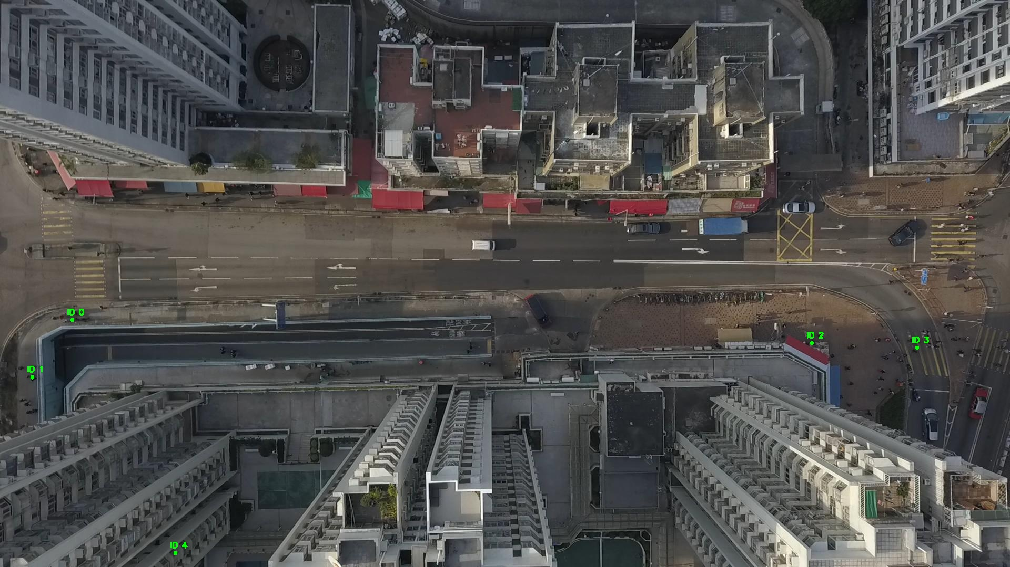

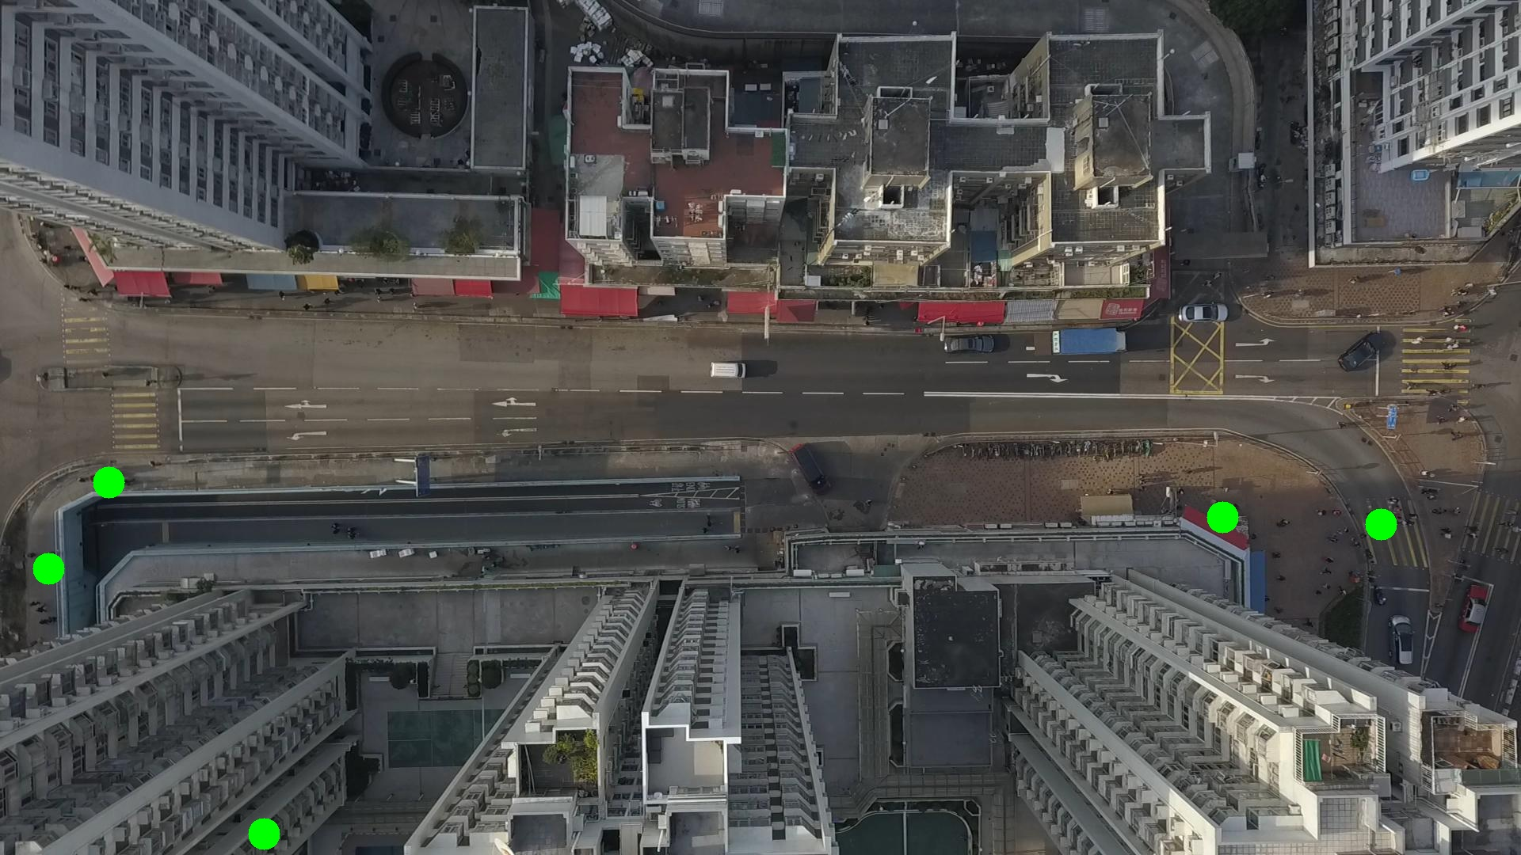

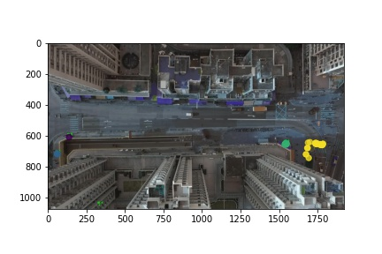

Silhouette metric for img015010.jpg is: 0.9239881210448636

Davies Bouldin metric for img015010.jpg is: 0.10004824840471571

Calinski Harabasz metric for img015010.jpg is: 284823.1713506481

ID 0: (139, 608)

ID 1: (51, 758)

ID 2: (1543, 653)

ID 3: (1763, 656)

ID 4: (333, 1053)

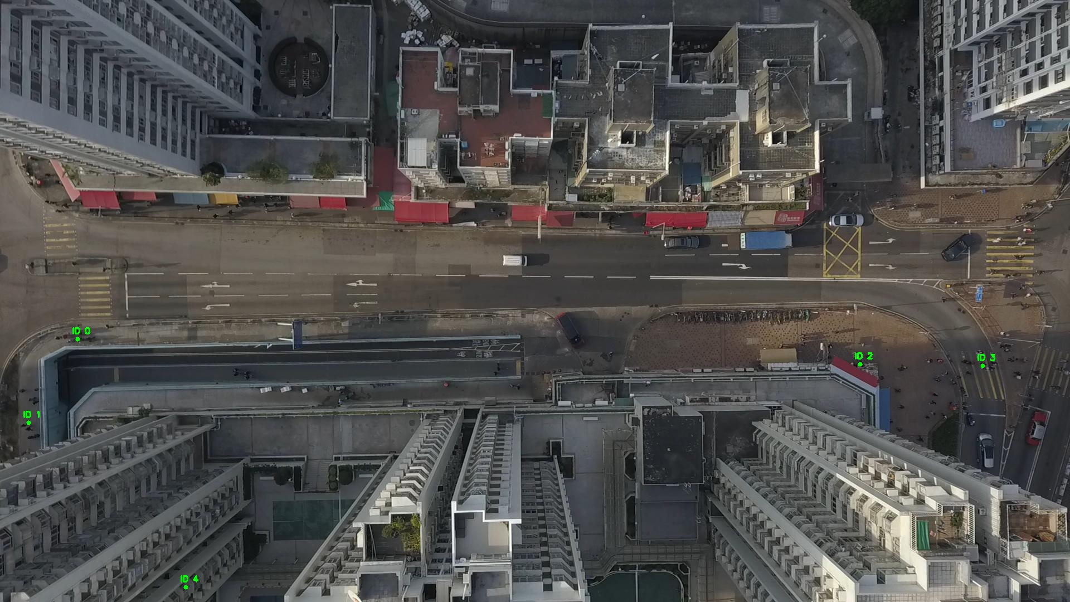

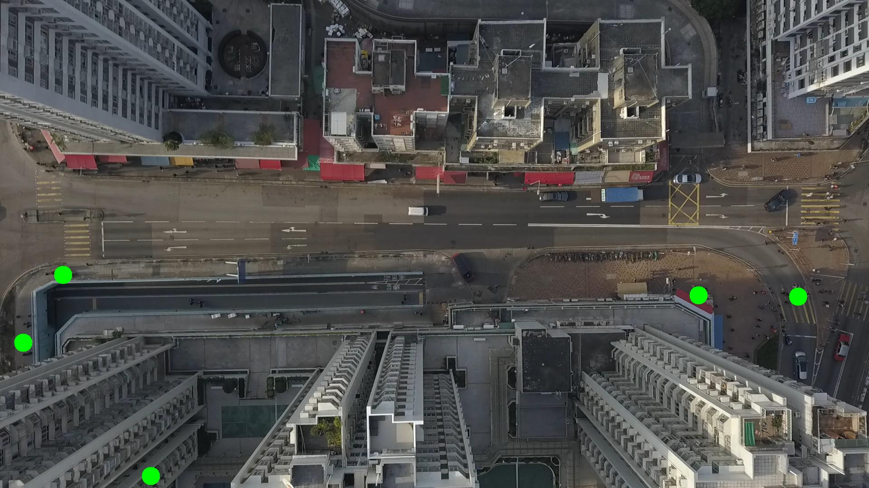

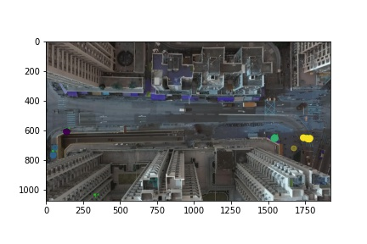

Silhouette metric for img015011.jpg is: 0.9342762978800044

Davies Bouldin metric for img015011.jpg is: 0.20231429544932017

Calinski Harabasz metric for img015011.jpg is: 775608.1214190148

ID 0: (139, 608)

ID 1: (48, 768)

ID 2: (1543, 653)

ID 3: (1773, 656)

ID 4: (333, 1053)

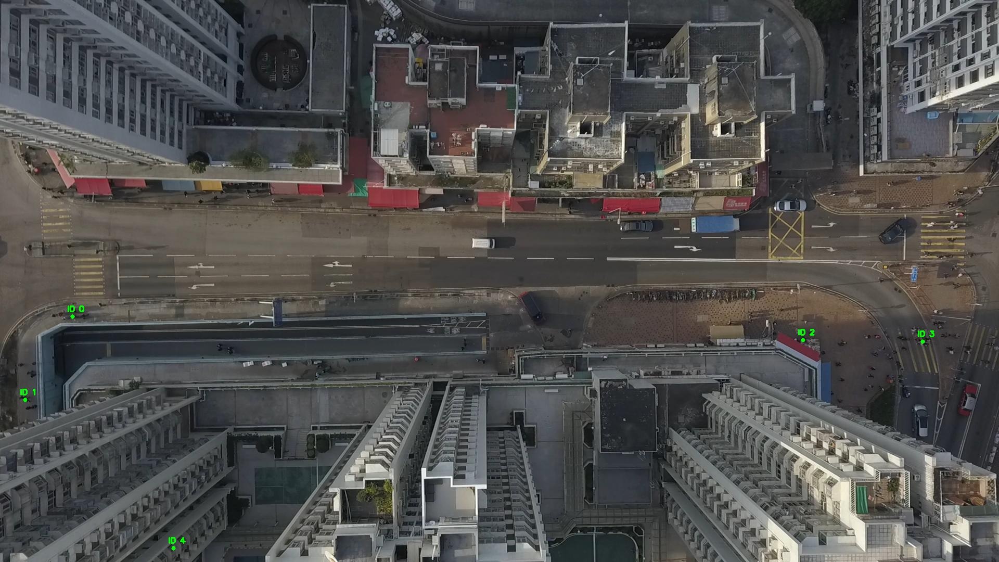

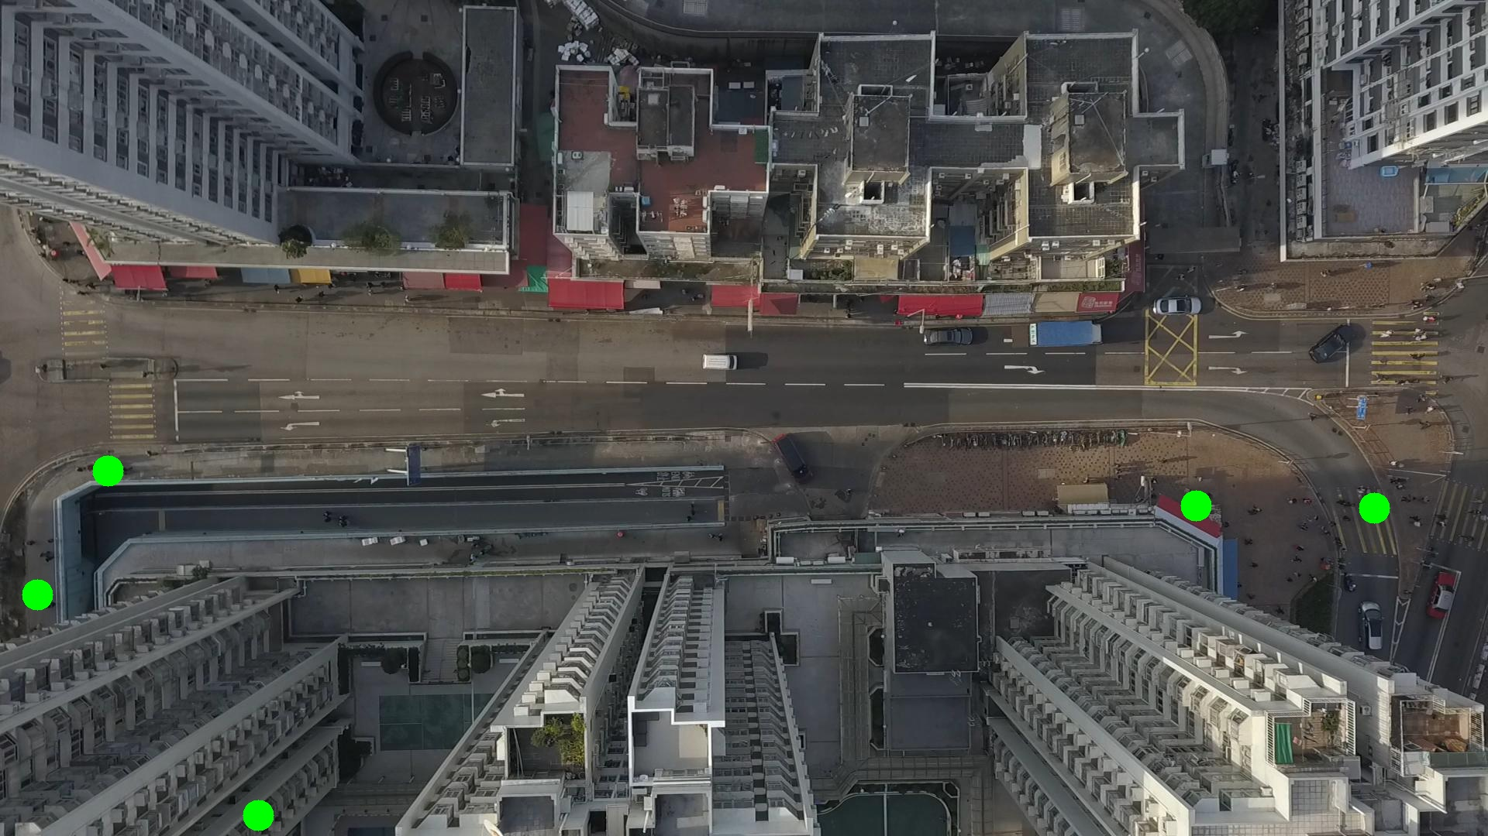

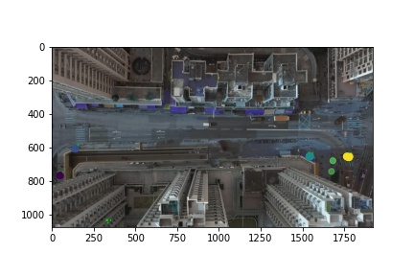

Silhouette metric for img015012.jpg is: 0.9654552112547155

Davies Bouldin metric for img015012.jpg is: 0.069721379676171

Calinski Harabasz metric for img015012.jpg is: 1538789.2623198584

ID 0: (138, 608)

ID 1: (48, 768)

ID 2: (1543, 653)

ID 3: (1780, 656)

ID 4: (333, 1053)

